Field Work Safety Guidelines for Researchers
University of Tennessee – Knoxville

Revised by Kristen Mecke on June 18, 2020

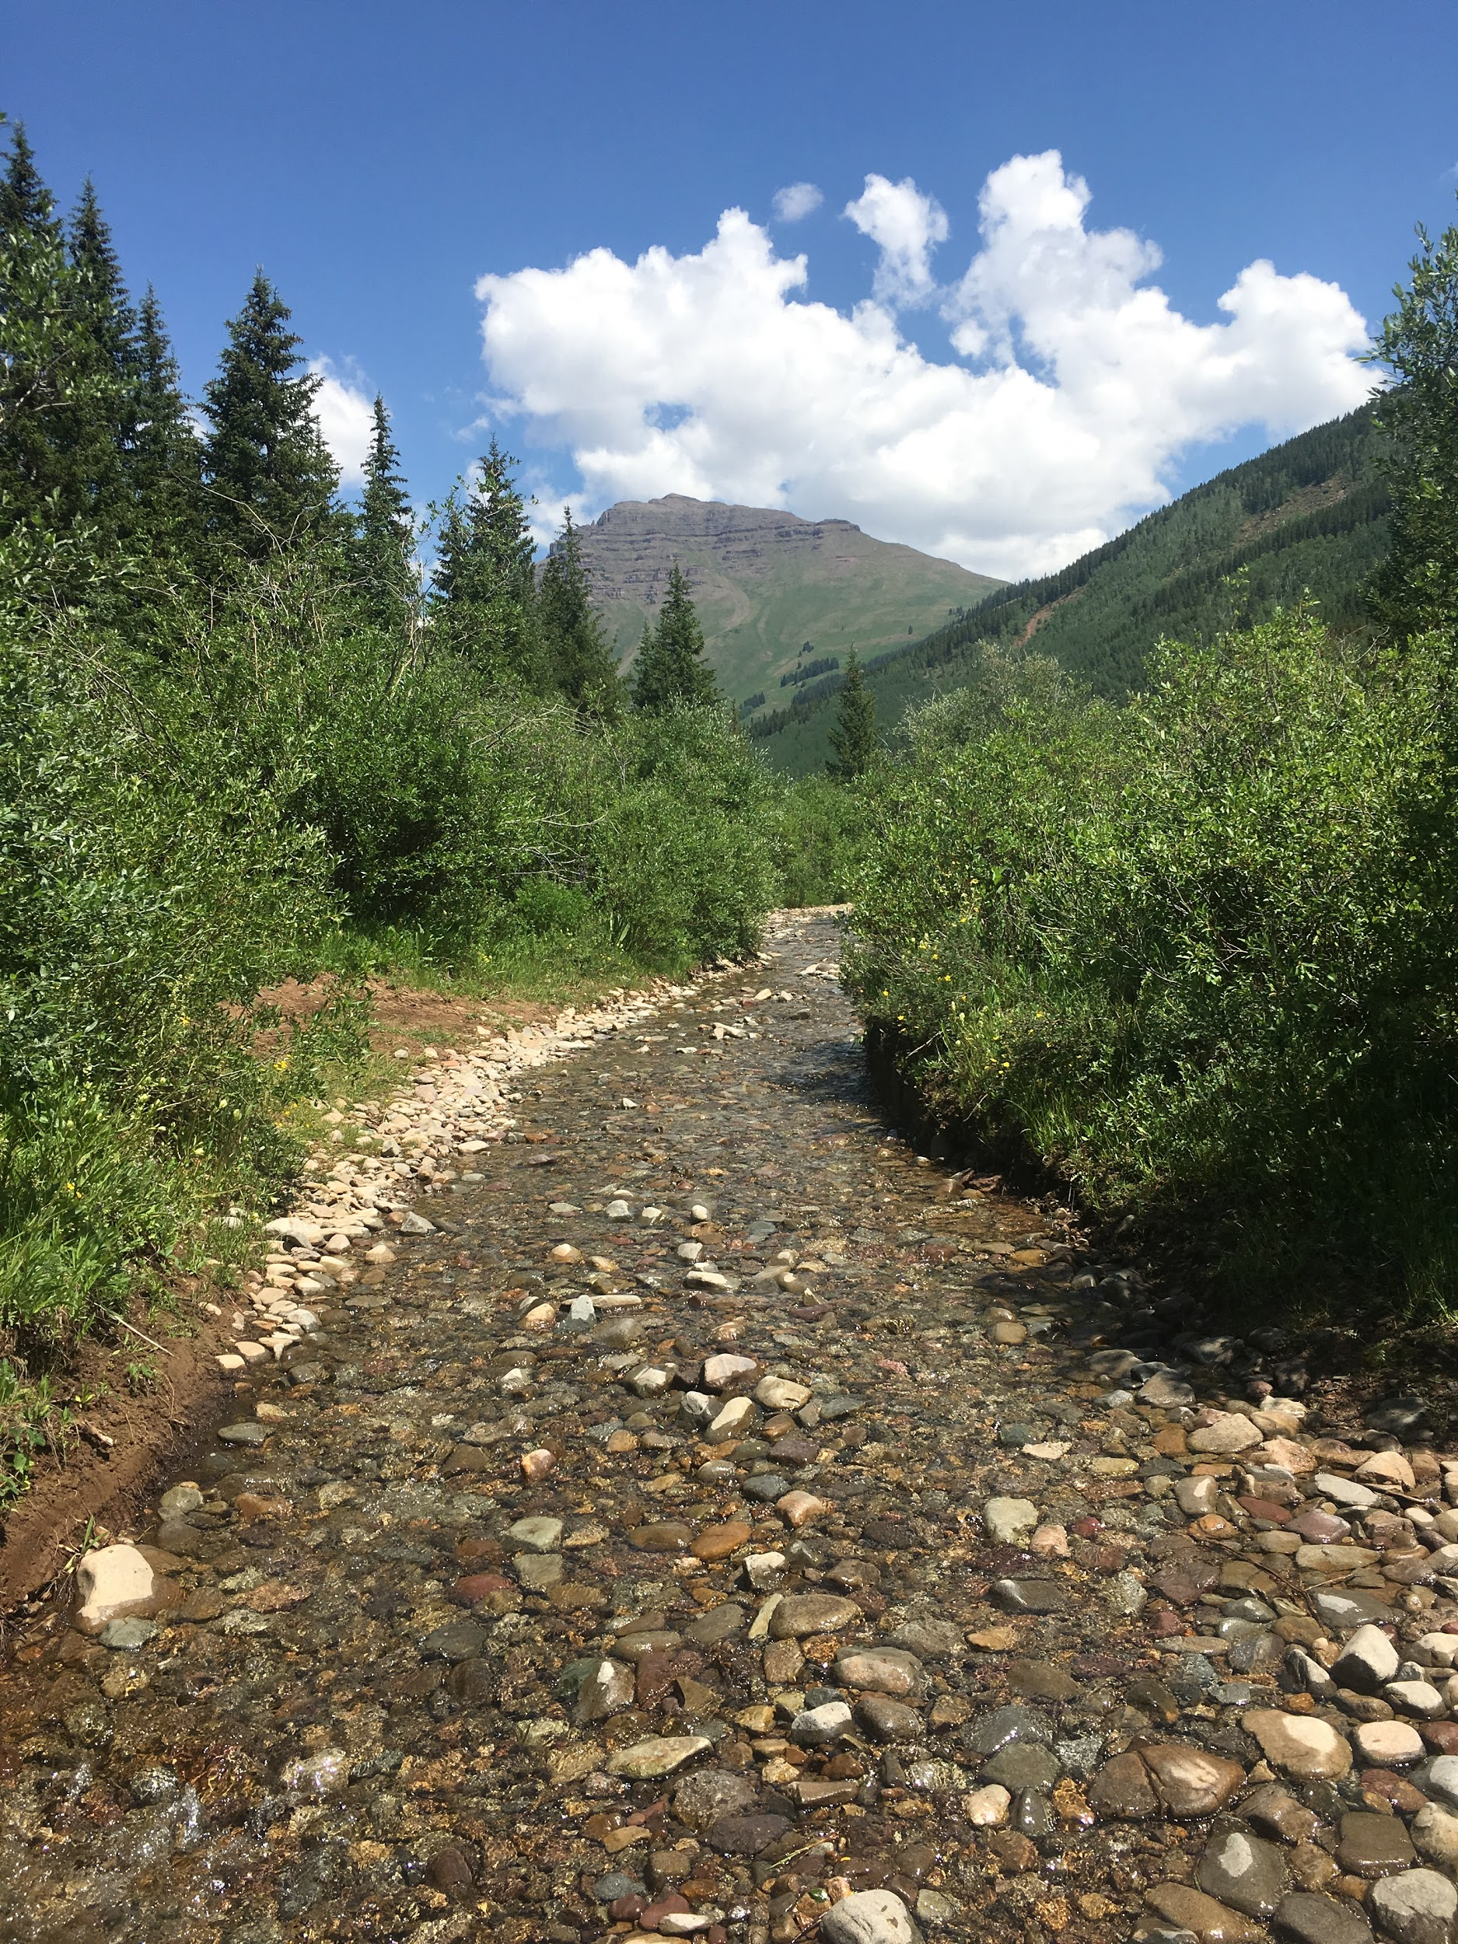
Photo by Stephanie Kivlin

Table of Contents
- Introduction
- General Field Safety Guidelines
- Before you leave
- While you are working
- Medical care and first aid
- Vehicle Safety
- Sexual Harassment & Anti-racism
- Physical and Environmental Hazards
- Animal and Insect Hazards
- Diseases
- Resources
Appendix 1. Local Hospitals and Police Contacts
Appendix 2. Field Safety Plan

- Introduction

What is considered fieldwork?

Fieldwork is any activity involving locations away from UTK campus. Field activities may include isolated locales, extreme weather, hazardous terrain, harmful wildlife, or lack of readily accessible emergency services; any of these conditions can expose
participants to significant risks to their health and/or safety.

The intent of this guide is to minimize health and safety risks associated with fieldwork by requiring a risk assessment in advance of fieldwork activities and by clearly defining responsibilities of those involved in planning and carrying out fieldwork activities.

“Fieldwork” consists of activities that are
- authorized by the University;
- conducted for the purpose of study, research, teaching, or provision of clinical services;
- undertaken by faculty, staff, students, and authorized volunteers;
- conducted at a location away from UTK’s main campus;
- conducted at field stations, nature reserves, or controlled sites. Some locations (such as a National Park) may have their own field safety guidelines to abide by when working in their vicinity.

“Fieldwork” does not include
- supervised study or work placements at the campus, buildings, or leased offices of other institutions;
- travel for conferences, seminars, meetings, or visits to other institutions.

- General Field Safety Guidelines

Before you leave

One of the best things you can do to stay safe while conducting field work is planning and preparing before you leave. A field safety plan must be filled out prior to your departure. The field safety plan can be found in Appendix 2. A field safety plan serves as a tool to document your hazard assessment, communication plan, emergency procedures, and training. This plan should identify hazards, as well as precautions and actions taken to address and mitigate those hazards. Instructions:
- Complete this field safety plan: insert specifics for your site and operations, delete irrelevant sections.
- Complete appropriate training for your site and operations (e.g. first aid, heat illness, task-specific training).
- Obtain immunizations and prophylaxis for your destination, if applicable (schedule 8 weeks in advance).
- Hold a pre-trip meeting with your group and/or supervisor to review your field safety plan, travel logistics, pack list (including first aid kit), personal safety and security concerns, and any remaining training needs.
Whenever possible, you SHOULD NOT work in the field alone. The “buddy system” is the safest way to work.

Permits: Much fieldwork conducted on city, state, and federally managed land requires a permit. Permits are often required for collection, activities disturbing resources, leaving field tags, going off trails, etc. Depending on the agency the process may take several days to several months. Make sure to plan ahead of time.

First Aid/CPR Training: First Aid and CPR training are available from a number of organizations, including Red Cross, which has classes available in Knoxville (and online). You can find more information online at www.redcross.org/take-a-class.

Vaccinations: If your trip involves traveling outside of the country, you should contact the Student Health Center, other medical clinic, or your personal care provider to learn about the required and recommended vaccinations for your location. Travelers’ Health through the CDC is a good resource to check for health advisories by country (https://wwwnc.cdc.gov/travel/). Some countries require proof of vaccinations prior to entry. A travel appointment should be scheduled as far in advance as possible since some vaccines are given as a series over a six-month period.

Travel advisories: If your trip involves traveling outside of the country, you should familiarize yourself with travel advisories in the area you are traveling to. More information can be found here: www.travel.state.gov/

Offline google maps: Google maps has an offline feature where you can download maps (for free) over Wi-Fi and your phone will still pick up your satellite location when you are not within cell service. This is primarily useful for navigating on roads or locating nearby services (gas stations, food, etc.). The maps are fairly reliable both within the US and Internationally. More information can be found here: Google Map Support.

Safety gear to take into the field:
- First aid kit
- Medication(s) as necessary
- Allergy treatment (Benadryl is always good to have in case of minor reactions)
  - If anyone in the group is allergic to bees/wasps they should inform the group and also bring an EpiPen into the field. At least one person in the group should be aware of how to administer the EpiPen.
  - If anyone in the group is allergic to poison ivy/oak, TecNu cleanser is a good thing to bring along.
- PPE (personal protective equipment) for the work being conducted. Examples include: long sleeves and long pants, sunscreen, insect repellent, hat, boots, gloves, hard hat, safety glasses (or sunglasses), etc.
- Water and water purification tablets or filtering devices (if multi-day in the back-country)
- Ample food supply for the time you will be out
- Vehicle emergency kit
- Flashlight
- GPS or maps – if you are going to be off trail, where you could become lost
- Cell phone and charger (even if you will be out of service, you may need it when you get back into service)
- Make sure you have your photo ID and insurance card with you, just in case an accident or injury does arise

While you are working

- You should check in with your group or supervisor on campus regularly and provide updates about any changes in the original plan, e.g. traveling to a different location than originally planned.

- Once fieldwork is completed, check-in with your on-campus group, P.I., or supervisor to let them know of your return.
- Avoid working alone. The “buddy system” is the safest way to work. If you are working alone, make sure to have a check-in person for frequent check-ins.

- Practice the 7 Leave No Trace principles
- plan ahead and prepare
- travel and camp on durable surfaces
- dispose of waste properly
- leave what you find
- minimize campfire impacts
- respect wildlife
- be considerate of other visitors

Medical care and first aid

- A first aid kit should be maintained at all times during the fieldwork. First aid kits are highly recommended for all off-campus operations. Kits and refills can be ordered from safety supply companies (Adventure Medical Kits make great first aid kits – but tons of others exist)
- If you take prescription medications, make sure you have enough for the time you will be in the field. If you have an allergy that requires the use of an EpiPen (e.g. bee, wasp, or hornet allergy), make sure to pack it. If you have a pre-existing condition and feel that you have a high-risk of injury it’s a good rule of thumb to inform the project leader just so someone is aware (e.g. allergies, past injuries such as knee or foot problems, etc.)
- Although not mandatory, it is a good idea for at least one person who is trained and certified in first aid and CPR to be present.
- Always call 9-1-1 before calling a supervisor, family member, etc.
- You should be aware of the closest hospital to your field sites, in case of an injury or other medical accident.
- If a university employee suffers a job-related injury or illness, he/she must notify his/her supervisor within 24 hours. A claim will have to be filed with EHS. Two steps must be taken.
- Step 1: INJURED WORKER WILL REPORT THE INJURY TO THEIR SUPERVISOR AND TO CORVEL
  - 1-866-245-8588 🡪 Option 1
  - This is a 24/7 Nurse Line
  - The NURSE will discuss the appropriate level of treatment needed and direct the injured worker to the nearest STATE-APPROVED treatment facility
  - If the injured worker agrees to self-care but later changes their mind, he/she must first call CorVel Option 2 to obtain authorization to treat
  - DO NOT go to the doctor prior to reporting the injury to CorVe
- Step 2: COMPLETE THE PAPERWORK
  - Paperwork can be found here: https://riskmanagement.tennessee.edu/workers-compensation/
  - Injuries MUST be reported within 3 business days.
- Vehicle Safety
UT Fleet Vehicle Checkout
More information on fleet vehicles and fleet vehicle check-out can be found at https://fleetmanagement.utk.edu/services/.
Safe Driving Practices
Secure materials for transport. Tools or equipment should be secured while being transported to prevent unsafe movement of materials. During a crash or when making sudden maneuvers, loose objects can slide around or become airborne, injuring the driver and any passengers. Objects that could become a hazard should be secured or stored outside the passenger compartment.
Seat belt use. Seat belts are the single most effective means of reducing deaths and serious injuries in traffic crashes (and it’s the law). As the most effective safety device in vehicles, they save nearly 12,000 lives and prevent 325,000 serious injuries in America each year. During a crash, anyone not wearing a seat belt will slam into the steering wheel, windshield, or other parts of the interior, or be ejected from the vehicle (you are 30 times more likely to be ejected if you are not wearing a seatbelt).
Distracted driving. Distracted driving is a factor in 25 to 30 percent of all traffic crashes. With hectic schedules and roadway delays, many people feel pressured to multi-task just to keep up with their personal and work-related responsibilities. More time on the road means less time at home or at work but "drive time" can never mean "down time." Since drivers make more than 200 decisions during every mile traveled, it's critical for employers to stress that when driving for work, safe driving is their primary responsibility.
Alcohol and drug impaired driving. Alcohol use is involved in 40 percent of all fatal motor vehicle crashes, representing an average of one alcohol-related fatality every 30 minutes. It is estimated that three in every 10 Americans will be involved in an impaired driving-related crash some time in their life. Alcohol, certain prescription drugs, over-the-counter medications, and illegal drugs can all affect a person's ability to drive safely due to decreased alertness, concentration, coordination and reaction time.
Fatigued driving. Fatigued or drowsy driving may be involved in more than 100,000 crashes each year, resulting in 40,000 injuries and 1,550 deaths. Sadly, these numbers represent only the tip of the iceberg since these crashes are seriously under-reported. These days, it's more important than ever for employees to be well rested, alert and sober on the road so that they are in a position to defend themselves from drivers who do not make the same choice. Train employees to make smart decisions when they're behind the wheel, on and off the job. If it can be avoided, one person should not drive more than 10 hours in one day.
Aggressive driving. People commuting to and from work and traveling for work purposes often find themselves caught up in bottlenecks and traffic delays, wasting their time and reducing their productivity. These situations create a high level of frustration that can spark aggressive driving behavior. The roadway is one place that being aggressive never pays. Aggressive driving acts include excessive speed, tailgating, failure to signal a lane change, running a red light and passing on the right. The best advice is to avoid engaging in conflict with other drivers and to allow others to merge.
More information on general vehicle safety can be found at https://www.osha.gov/Publications/motor_vehicle_guide.html.
Alternative Vehicle Safety: If you are going to be operating golf carts, ATVs, or other non-traditional motor vehicles, you should take the Alternative Vehicle Online Safety course offered by EHS. To access go to https://ehs.utk.edu/index.php/training/ 🡪 enroll in EHS Canvas course 🡪 view modules 🡪 click on Alternative Vehicle Safety.
Off-roading: Driving off road is often necessary for remote field work but inherently risky. If you will be traveling off-road to access field sites, make sure the vehicle operator understands how to use the appropriate Hi/Lo 4WD options. Do not cross swollen streams or areas that are exceptionally wet. Always make sure to have a road safety kit with spare tire and jack.
- Sexual Harassment & Anti-racism

Sexual Harassment

Sexual harassment is defined as: Unwelcome sexual advances, request for sexual favors, and other verbal or physical conduct of a sexual nature constitute sexual harassment when:
- Submission to such conduct is made either explicitly or implicitly a term or condition of an individual’s employment or status in a course, program, or activity;
- Submission to or rejection of such conduct by an individual is used as a basis for employment or academic decisions (grades, academic progress, internship, etc.) affecting the individual; or
- Such conduct substantially interferes with an individual’s work performance, academic performance, or creates an intimidating, hostile, or offensive work environment.

University of Tennessee’s full sexual harassment policy can be found here: https://titleix.utk.edu/wp-content/uploads/sites/75/2019/08/2019-2020-Title-IX-Policy-without-Appendices-vFINAL.pdf

Anti-racism and Title VI

The University of Tennessee is committed to providing a work and study environment that is culturally inclusive and free from racial discrimination and harassment. The University encourages research and community service activities that raise awareness and promote cultural diversity and inclusiveness. The University will not tolerate any racial discrimination or harassment under any circumstances.

Title VI of the Civil Rights Act of 1964 is the federal law that protects individuals from discrimination on the basis of their race, color, or national origin in programs that receive federal assistance. Higher education is included under this act.

Racism is defined as: prejudice, discrimination, or antagonism directed against someone of a different race, based on the belief that one’s own race is superior. Race can be defined as not only background, but also family, culture, history, beliefs, a sense of place and belonging with others who share the same or similar things.

Racial discrimination is defined as: a person or group being treated less favorably, or not given the same opportunities, as others in a similar situation because of their race, color, descent, national or ethnic origin, or immigrant status. Examples of discrimination include:
- Denying program services, aids, or benefits
- Providing a different service, aid, or benefit, or providing them in a manner different than they are provided to others
- Segregating or separately treating individuals in any matter related to the receipt of any service, aid, or benefit.

Harassment is defined as: unwelcome behavior that makes a person feel belittled, intimidated, offended or apprehensive and, taking into account all the circumstances, could reasonably have been anticipated to have this effect.

University of Tennessee’s Office of Equity and Diversity has resources available here: https://oed.utk.edu/

If you believe that you or others protected by Title VI have been discriminated against, you should file a formal complaint with the University of Tennessee. There is a form located on the Office of Equity and Diversity’s webpage, under file a complaint discrimination complaint form. You can also call Jenny Richter (865-974-2498) at the Knoxville campus (each UT campus has a different contact that can be found on the OED webpage). All complaints are evaluated and investigated to attempt to resolve any violations found.

- Physical and Environmental Hazards

There are many general physical and environmental hazards that exist in nearly every location worldwide. All field researchers, regardless of the work location, should read through Table 1 to learn more about some general physical and environmental hazards.

Table 1. Physical and Environmental Hazards

Hazard | Location | Cause | Symptoms | First Aid | Prevention
Boating accident | Worldwide | Lack of proper training, fatigue, severe weather, alcohol impairment | Various trauma injuries or death | Seek medical attention for serious injuries | Proper training, don’t drive while impaired and don’t speed
Burns | Worldwide | Touching a hot surface, especially metal; contact with flames | Pain, redness, swelling, tissue damage, blisters (2°), charring (3°) | Cool burn with cool water, pain-reliever, 2/3° burns should seek medical attention | Use gloves when handling hot objects
Carbon Monoxide | Worldwide | Running a vehicle or burning a stove in an enclosed space | Severe headaches, disorientation, agitation, lethargy, coma, stupor | Remove victim to fresh air and perform CPR if needed | Keep area adequately ventilated.
Decompression sickness (the bends) | Worldwide; high altitudes and scuba diving | Diver surfacing too fast or rapidly changing elevations at high altitudes | Pain around major joints, fatigue, rash, itching, inner ear ringing | Seek medical attention immediately. | Acclimate for recommended times (e.g. follow dive table recommendations)
Dehydration | Worldwide | Not enough water intake | Dark urine, lethargy, constipation, light-headedness | Drink plenty of fluids, take rest breaks, minimize caffeine intake | Drink plenty of water (at least 2 quarts/day). Drink more if in a warm climate.
Drowning | Worldwide | Inhalation of water leading to respiratory impairment. | Apnea or death | Remove victim from water, turn head to side, CPR, seek medical attention immediately. | Know how to swim, be aware of water safety, have life preservers (PFDs) and rescue equipment available.
Electrical shock | Worldwide | Damaged electrical cords, improper wiring, improper grounding | Cardiac arrest, shaking, numbness, paralysis, burns, other physical injuries | Provide burn first aid as needed. Seek medical attention if serious. | Inspect cords for damage, replace or repair ASAP
Extreme weather | Worldwide | Snow storms, blizzards, lightening, tornadoes, hurricanes, monsoon, floods | Severe weather could result in physical injury or death | Seek shelter immediately | Be aware of special weather concerns, and changing weather. Bring appropriate equipment.
Frostbite | Worldwide; cold climates | Exposure to extremely cold temperatures | Waxy, whitish numb skin, swelling, itching, burning, and deep pain as the skin warms | Slowly warm the affected area (DO NOT RUB), seek medical attention. | Dress in layers. Cover your extremities with warm hats, face mask, gloves, socks, and shoes.
Heat Exhaustion | Worldwide; hot climates | Prolonged physical exertion in a hot environment | Fatigue, excessive thirst, heavy sweating, cool and clammy skin | Cool the victim, treat for shock, and slowly give water or electrolyte replacer. | Acclimate to heat gradually. Drink plenty of liquids. Take frequent rest breaks.
Heat Stroke | Worldwide; hot climates | Prolonged physical exertion in a hot environment | Exhaustion, light-headedness, red skin that is warm to the touch | Cool the victim, replenish fluids, and seek medical attention. | Acclimate to heat gradually. Drink plenty of liquids. Take frequent rest breaks.
High altitude sickness | Worldwide; high altitudes | Decreased oxygen and increased breathing rate | Headache, nausea, weakness | Use supplemental oxygen and decrease altitude | Allow your body to acclimate to elevation slowly
Hunting season | United States | Local hunting seasons and regulation vary, be familiar with local regulations | A hunting accident may result in serious injury or death | Seek medical attention immediately. | Wear appropriate clothing, avoid animal-like behavior, be aware of regulations
Hypothermia | Worldwide; cold climates | Prolonged exposure to cold temperatures | Shivering, numbness, slurred speech, fatigue | Remove cold, wet clothes, put on dry clothes or use a blanket or skin-to-skin contact, drink warm liquids, seek medical attention immediately | Dress in layers, wear appropriate clothing, avoid getting damp from perspiration or water
Impure water | Worldwide | Harmful organisms living in “natural” water sources | Gastrointestinal, flu-like symptoms | Drink clear liquids, slowly introduce mild foods  (e.g. rice, bananas). See doctor if no improvement | Carry your own water. Treat water before drinking (e.g. purifiers, tablets)
Poisonous plants | North America | Exposure to poison ivy, poison oak, or poison sumac plants | Itch rash, red and/or swollen skin | Anti-itch medications, if you have trouble breathing seek medical care immediately | Avoid contact with poisonous plants, wash clothes/skin with TecNu (or soap/water) immediately after exposure.
Red/brown tides | Both sides of the Atlantic, off FL, and along the Pacific coast to AK | Algal blooms | Respiratory distress, dead fish, discolored water | Seek medical attention if you experience respiratory distress | Avoid areas where tides are in bloom
Slips, trips, falls | Worldwide | Loose, irregular, or slippery surface, wrong footwear, obstruction, inattention | Strains, fractures, and contusions to the head, wrist, elbow, shoulder, back, hip, or knees | Seek medical attention for serious injuries | Wear appropriate footwear, adequate lighting, be aware of your surroundings
Sunburn | Worldwide | Excessive exposure to the sun | Irritated skin, pink/red in color | Apply cool water, aloe, or other cooling lotion to affected area. | Wear long sleeved clothing and a hat. Apply sun screen with at least SPF 30.
Theft | International |  |  | Report to local authorities | Keep wallet in front pocket (out of site), carry shoulder bag diagonally and in front of you, under your arm.
Vehicle accident | Worldwide | Fatigue, impaired driving, driver error, roadway & vehicle factors | Various trauma injuries or death | Seek medical attention for serious injuries | Obey traffic laws, wear seatbelt, don’t drive impaired, speed, or drive when tired
Violence caused by political or military conflict | International |  |  | LEAVE THE AREA AS SOON AS POSSIBLE | Be aware of current travel advisories.

What to do if you find yourself lost:
The best thing you can do is to prepare in advance. Always expect the unexpected…pack more than enough food/water, have a compass (that you know how to use) or a charged GPS, have a map of your route (and know how to read it), pack layers of clothing, space blanket, flashlight, and matches. Always inform someone of your route and approximate return.

If you are lost… STOP - S(top) T(hink) O(bserve) P(lan)

S(top) – as soon as you realize you may be lost: stop, stay calm, and stay put. Panic is your worst enemy.

T(hink) – Go over in your mind how you got to where you are. What landmarks can you see? Do not move unless you have a specific reason to move.

O(bserve) – Get our your compass and determine the directions based on where you are standing (do not walk around). If you are on a trail, stay on it. As a very last resort, follow a drainage or stream downhill. This is often difficult and could be dangerous, but could lead to a trail or road.

P(lan) – Based on your observations, come up with some possible plans, think them through, then act on one of them. If you are not confident on a route, its best to stay put. If its nightfall, you are injured or are near exhaustion, stay put.

Self-rescue tips:
- Stop and rest when you start to feel tired. Don’t wait until you are exhausted.
- Your body can’t hike hard and digest food at the same time. Rest in the shade for at least 30 minutes when you stop to eat. If you are still tired after 30 minutes, continue to rest.
- Make sure to drink enough water to avoid dehydration. Symptoms include heading, feelings of irritation and frustration and more tiredness than warranted.
- Stop and fix small problems while they are still small. If you ignore your body and keep pushing, the pain or illness will only get worse and make recovery more difficult. Avoid hiking between 10 a.m. and 4 p.m. on hot days. If you are on a trail between those hours, find a shady spot and stay there until the temperature cools down. Adjust you’re hiking pace to what you can comfortably maintain and rest when you feel the need.

Extreme weather precautions: Always be aware of the weather prior to venturing into the field. In mountainous regions, weather can change rapidly, always be aware of cumulonimbus clouds building or dark clouds moving in. Typically in the mountains, afternoon is when potentially dangerous storms tend to occur.

High winds: High winds can occur during a severe thunderstorm, with a strong weather system, or can flow down a mountain. Sustained winds of 40-50 mph can result in isolated wind damage. Widespread significant wind damage can occur with higher wind speeds. During strong thunderstorms, straight line wind speeds can exceed 100 mph. High winds can blow objects around and pose a significant threat to your safety. If you are driving, keep both hands on the wheel and drive at a reduced speed. If you are outside, take shelter in your car if you are not near a sturdy building. If possible, drive to a nearby sturdy building. Otherwise, move your car to a location where it is less likely to be hit by falling trees or power lines. If no shelter is available avoid trees, power lines, and the side of the road. Keep in mind that power lines that are laying on the ground may be live. Do not go near them! Try to find a place that will block blowing or falling debris. Keep a distance from high profile vehicles such as trucks, buses and vehicles towing trailers. One strong gust of wind can be enough to flip one of these trailers onto its side.

Extreme heat: Heat related illness can be prevented. When working outdoors in direct sunlight or when performing prolonged/strenuous work, the heat index can be up to 15 degrees warmer than the ambient temperature. Make sure to drink plenty of water (CDC recommends 8 oz every 15-20 min you are working outside in heat indices over 100°). Take frequent breaks in the shade, if possible (OSHA recommends a 15-min break every hour when working in heat indices over 100°). Electrolyte replacements are also a good idea 1-2x throughout the day.

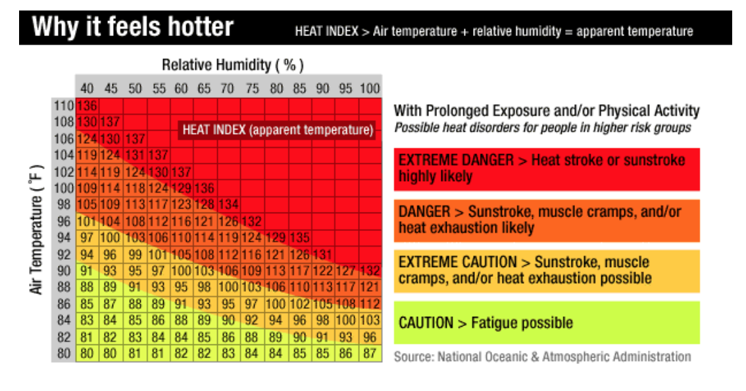

Blizzards: Stay hydrated and as warm as possible. Keep your body covered. Always wear a hat and gloves to reduce heat loss. Melt snow prior to consuming. Exercise to stay warm and maintain circulation, but not hard enough to break a sweat. Stay in one place as long as practical and safe.

Tornadoes: Know the signs of a tornado. Strong persistent rotation in the cloud base, whirling debris on the ground under cloud base, hail or heavy rain followed by either dead calm or a fast, intense wind shift, loud roar or rumble. If you can take shelter in a sturdy building. If not, lie flat and face-down on low ground (ditch or flat ground) protecting your back and head, with your arms, from flying debris. Get as far away from trees and cars as you can.

Lightning storm or severe thunder storm: As soon as you hear thunder, you should seek shelter. Lightening can strike as far as 10 miles from the storm. Avoid bodies of water. If you can, take shelter in a sturdy building or your vehicle. If not, find a low spot away from trees, fences, and poles. If your skin tingles and hairs stand on end, lightening is about to strike. Crouch down immediately, balancing on the balls of your feet, placing hands on knees with head between them.

Flooding: If you get caught in a flash flood, DO NOT drive through or over a flooded road or bridge. 6 inches of water is enough to stall a car and one foot of water can float a car. Back up and try a higher route. Do not stay in a flooding car. If your car is being overtaken by water, get out and seek higher ground. If you are stranded in a tree or building do not leave it to enter flood water.

Earthquake: Do not rush indoors. If you are outside, make your way to an open space away from buildings, trees, and poles. This will help you avoid any falling debris. Once you are in an open space, remain there until the earth stops shaking. If you are in a moving vehicle, stop the vehicle as soon as you are able and remain inside. Do not park near trees, utility lines, over-passes, bridges, or gas stations. Remain calm!

Wildfire: The best thing you can do for wildfires is be prepared. If you are working in a wildfire prone area, plan back-up escape routes prior to going out. Monitor the weather conditions frequently. Know the difference between different watches and warnings.

- Red Flag Warning: Take Action. Be extremely careful with open flames. NWS issues a Red Flag Warning, in conjunction with land management agencies, to alert land managers to an ongoing or imminent critical fire weather pattern. NWS issues a Red Flag Warning when fire conditions are ongoing or expected to occur shortly.
- Fire Weather Watch: Be Prepared. A Watch alerts land managers and the public that upcoming weather conditions could result in extensive wildland fire occurrence or extreme fire behavior. A watch means critical fire weather conditions are possible but not imminent or occurring.
- Extreme Fire Behavior: This alert implies a wildfire likely to rage of out of control. If is often hard to predict these fires because such they behave erratically, sometimes dangerously. One or more of the following criteria must be met: moving fast (high rate of spread), prolific crowning and/or spotting, presence of fire whirls, or strong convection column.

If you are ordered to leave an area, LEAVE. If you are not ordered to evacuate: Do not light campfires, bonfires, candles or anything else that could blow over and start a fire. If you smoke, be sure to extinguish your cigarette or cigar before disposing of it. Never through a burning item out a window. Bag up trash, clippings and other easily flammable items. Keep your vehicle’s gas tank full in case you need to evacuate.

Poisonous plants: Most of the time coming in contact with these plants are more of a nuisance than a serious health threat. Know your plants and minimize exposure to potentially dangerous ones. Do not eat plants that you are not familiar with. Dress properly, wearing long sleeves and long pants to minimize contact. If you come into contact with a potentially poisonous plant, wash the area of skin or gear that came in contact with it with dish soap or TecNu (specifically designed for removing urushiol). Do not burn unknown plants, as the smoke may contain poisonous compounds.

The most frequently encountered poisonous plants are poison ivy, poison sumac, and poison oak (although there are plenty of others). The oil produced by this group of plants is urushiol. Urushiol can produce an allergic reaction which often results in dermatitis (rash) in the area that came in contact with the oil. This rash is typically characterized by itchy bumps and blisters that appear within 24-72 hours of exposure. Eventually the blisters break and crust over. Sometimes reactions can become systemic (affects other parts of your body). You cannot build immunity to urushiol, the more you are exposed to the oil the more likely you are to develop dermatitis or a systemic response. If you develop severe allergies to urushiol you may also develop allergies to mango, cashews, and pistachios which are closely related.

Poison ivy: Poison ivy leaves are compound and consist of 3 leaflets. In each set, the middle leaflet has a longer stem than the two side leaflets. Typically the leaves are mitten shaped. Poison ivy can grow on the ground or as a vine. (photo credit: poison-ivy.org)

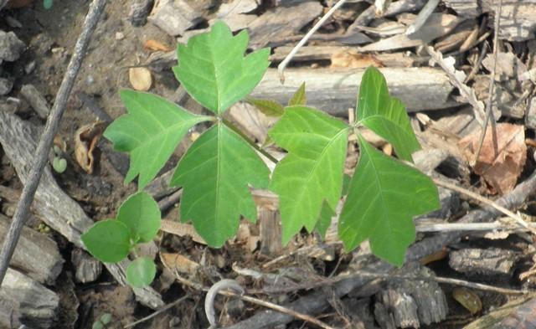

Poison oak: Poison oak leaves are compound and consist of 3 leaflets. Often the leaflets resemble white oak leaves (wavy margins) but they can have smoother margins. The growth form is typically a small shrub. The plants produce fuzzy berries. (photo credit: poison-ivy.org)

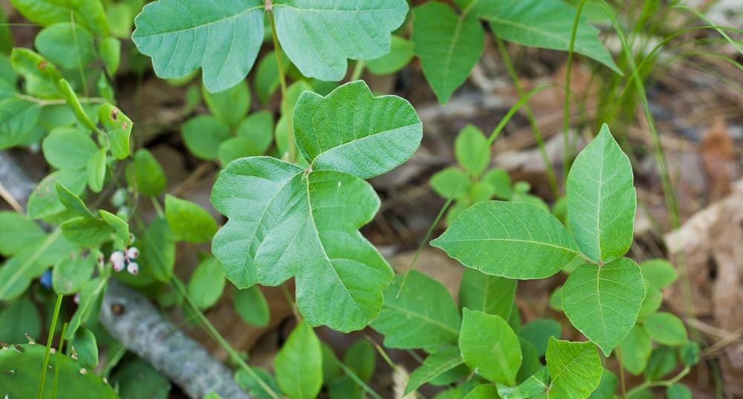

Poison sumac: Poison sumac have pinnately compound leaves, with 6-12 leaflets and an additional leaflet at the tip. The leaflets point upward most of the year. Stems are mostly red. In the winter they produce white/gray berries. The growth form is a shrub or tree (5’-20’). (Photo credit: poison-ivy.org)

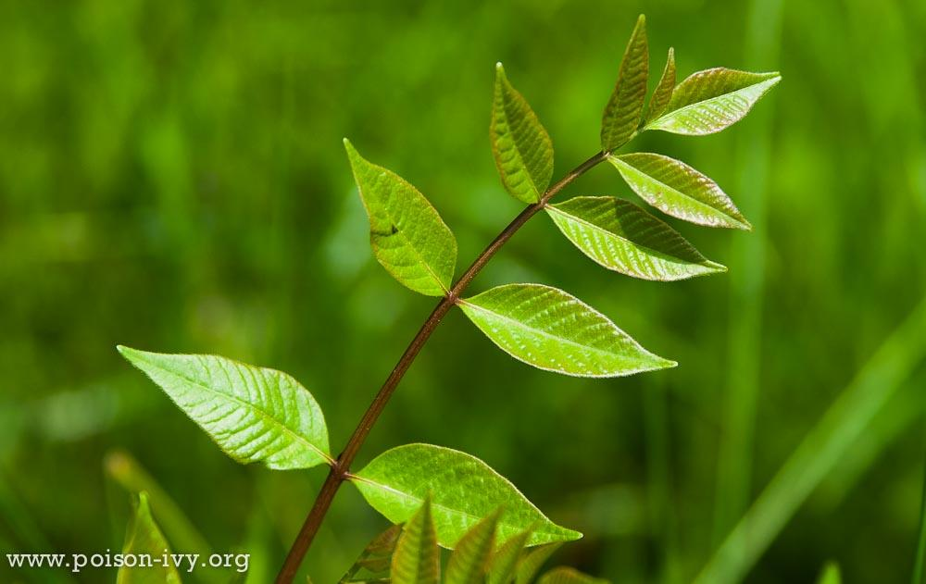

Working in a burned areas (wildfire or prescribed): Personal protective equipment (PPE) should always be worn. Recommended PPE includes: hard hats, safety glasses, leather gloves, reflective vests, and boots. If performing dust-creating operations (such as shoveling soil) a respirator may need to be worn. Always work in pairs. Be aware of your surroundings and avoid working and taking breaks near snags (standing dead or dying tree), as they are unstable after a fire and may fall. Be observant of the ground, fires can create plenty of tripping hazards (e.g. downed logs, exposed rock).

Ice safety: Working on ice and glaciers can be extremely risky. If you break through the ice into several feet of flowing water, it will be very difficult for you to get out and very hazardous for a co-worker to try to rescue you. The same goes for crevasses in glaciers. Use extreme caution and good judgement. PPE should always be worn. Recommended PPE includes: crampons, harnesses, ropes, and warm layers. Carefully evaluate site conditions including ice strength. If the risk is too great, don’t continue. These two resources provide detailed information about safety measures for working on ice: https://work.alberta.ca/elearning/icesafety/pdfs/ice_safety_field_guide_2009.pdf
https://water.usgs.gov/admin/memo/policy/wrdpolicy00.03.att.htm

Cave and mine safety: Hazards related to entering confined spaces include: physical hazards from unstable structural integrity and low overhead clearance, respiratory hazards from unsafe environmental conditions, such as hydrogen sulfide gas or lack of oxygen, and increased risk due to access limitations, unreliable communications, and isolated, often dark and rugged/ uneven conditions. It is a standard precaution for workers to wear a hardhat, headlamp, and carry a 4-gas meter (that measures hydrogen sulfide, combustible gas, carbon monoxide, and oxygen levels simultaneously) to verify safe conditions and adequate oxygen levels prior to entry into a confined space.

Boating safety: To operate a motorized vessel greater than 8.5 HP in the state of Tennessee, you MUST have a Tennessee Boater Education Certificate issued by TWRA. More information can be found here: https://www.tn.gov/twra/boating.html. Make sure your vessel is equipped with enough life jackets as people, fire extinguishers, and communication tools (e.g. phone, weather radio, etc.). Hurricanes, fog, thunderstorms, and rapid wind shifts are the most dangerous situations on the water.

Fog: Chances are when you are on the water, you will occasionally encounter fog, making navigation a challenge. Fog forms when air over a warm water surface is transported over a colder water surface, resulting in cooling and condensation. Fog is usually considered dense if it reduces visibility to less than 1 mile. It can form quickly and catch boaters off guard. Visibility can be reduced to a few feet, disorienting boaters. Learning to navigate through fog (or avoiding it) is critical to safe boating.
- Slow down to avoid collisions.
- Turn on all of your running lights, even in daytime.
- Listen for sounds of other boats that may be near you or for fog horns and bells from nearby buoys.
- VHF NOAA Weather Radio should broadcast important information concerning the formation, movement or dissipation of the fog. Pay close attention.
- If your vessel has radar, use it to help locate dangers that may be around you.
- Use GPS or a navigation chart to help obtain a fix on your location.
- If you are unable to get your bearings, stay put until the fog lifts but make sure you are in a safe location.
- Be familiar with horn and bell sounds you should produce to warn others around you when in dense fog.
- Have a compass available. Even if you don't know where you are in the fog, with a compass you can determine the direction you are navigating.

Thunderstorms: Thunderstorms can develop quickly and create dangerous wind and wave conditions. Thunderstorms can bring shifting and gusty winds, lightning, waterspouts, and torrential downpours, which can turn a day's pleasure into a nightmare of distress. There are no specific warnings or advisories for lightning but all thunderstorms produce lightning. A lightning strike to a vessel can be catastrophic, especially if it results in a fire or loss of electronics. If your boat has a cabin, stay inside and avoid touching metal or electrical devices. If your boat doesn't have a cabin, stay as low as you can in the boat. Boaters should use extra caution when thunderstorm conditions exist and have a plan of escape. Mariners are especially vulnerable as because you may be unable to reach port quickly. Do not venture out if thunderstorms are a possibility. If you do venture out and recognize thunderstorms nearby, head to port or safe shelter as quickly as possible. Ultimately, boating safety begins ashore with planning and training. Keep in mind that thunderstorms are usually brief so waiting it out is better than riding it out.

Monitor the weather conditions frequently and know the difference between watches and warnings.

- Marine Warning: A warning is issued when dangerous conditions are imminent or occurring. If you are in at sea, take immediate action to protect yourself and your boat.
- Marine Watch: A watch is issued when conditions are favorable for a specific hazardous weather event to occur. This is the time to start preparing, not when a warning is issued.

Inland boating: If you are caught out in a storm and can't get back in time, here's what do to:
- Divers should get out of the water and get to safety. If that is not possible, dive as deep as possible for the duration of the storm or as long as possible.
- Stop all activities when there is lightning or when weather conditions look threatening. The first lightning strike can come out of a clear blue sky many miles ahead of an approaching thunderstorm cloud.
- If your boat has a cabin, stay in the center of the cabin. If you don't have a completely enclosed cabin, stay low.
- Keep arms and legs in the boat. Do not dangle them in the water. Water conducts electricity from lightning.
- Disconnect electronic equipment, including the radio, throughout the duration of the storm.
- Lower, remove or tie down the radio antenna and other protruding devices if they are NOT part of a lightning protection system.
- If someone is struck by lightning, perform CPR immediately if needed. Victims do not carry an electrical charge after being struck. There is no danger to you in offering emergency aide..
- If a boat has been struck by lightning, or is suspected of having been struck, check the electrical system and the compasses to ensure that no damage has occurred.

- Animal and Insect Hazards

Hazardous animals and insects are present worldwide. General familiarity and safety procedures can protect you from these dangers. All field researchers, regardless of the work location, should read through table 2 for some general guidelines to avoid unwanted animals and insects.

• Wear insect repellent (DEET or Picaridin). Mosquito-borne illnesses are responsible for more than a million deaths each year. Tick-borne illnesses are responsible for 60,000+ sicknesses in each year in the US alone.
• Treat clothing and gear with permethrin, especially if you are working in a location with a high tick density.
• Wear clothes made of tightly woven materials, and tuck pants into boots.
• Use netting to keep pests away from food and people.
• Keep garbage in rodent-proof containers and stored away from your campsite or work area. Food crumbs and debris may attract insects and animals.
• Thoroughly shake all clothing and bedding before use.
• Do not camp or sleep near obvious animal nests or burrows.
• Carefully look for pests before placing your hands, feet or body in areas where pests live or hide (wood piles, crevices, etc.).
• Avoid contact with sick or dead animals.
• Minimize the amount of time you use lights after dark as they may attract pests and animals.
• Be aware of the appearance and habitat of pests likely to be found, such as those described in Table 2.
• Carry a first aid kit with you on any excursion so you can treat bites or stings. If the pest is poisonous or if the bite does not appear to heal properly, seek medical attention immediately.

Table 2. Animal and Insect Hazards

Type | Location | Most dangerous species | Defensive action | First aid | Prevention
Alligators and Crocodiles | Worldwide; tropics and sub-tropics | American alligator, estuarine crocodile, Nile crocodile | Do not provoke an  alligator or  crocodile. | Seek medical  attention for serious  injuries or wounds. | Avoid waters known to be home to crocodiles or  alligators. Keep at least 30 feet away  from any crocodile or alligator.
Ants | Worldwide | Fire ant, army ant, bullet ant, bulldog ant | Do not disturb ant mounds/nests. | Apply a cold compress to reduce swelling. Apply an anti-itch cream. Take antihistamine if needed. | Always wear appropriate footwear, avoid walking around barefoot. Do not disturb known ant beds.
Bears | North America | Black bear, grizzly bear, polar bear | Never run.  Identify yourself by waving your arms and talking calmly. Make yourself look as large as possible. Grizzly/Polar bears: Bear spray. Play dead if attacked, hands clasped behind head to protect. Black bears: fight back or escape to a building/car. | Seek medical attention immediately for serious injuries and wounds. | Hike/travel in groups. Do not give a bear food. Do not leave a pack behind with scented items. Be cautious when in bear country (noise is a good deterrent – e.g. bells on pack, talking to partner). Carry bear spray if you are in grizzly bear country. Be especially cautious if you see cubs.
Bees, wasps, hornets | North America | Africanized killer bees, bees, wasps, hornets | Do not swat or kill – this may  elicit an attack response from  other bees/wasps. Leave the area immediately  and quickly.  If being chased move into a  closed area if possible. | Remove the stinger quickly.  Place an ice pack and elevate  to heart level. Use an  antihistamine if needed. Use EpiPen if allergic to avoid possible death. | Bring medication if you have an allergy (the sting may be fatal). Keep scented foods and meats covered. Wear shoes outside. Avoid wearing bright colors, flower  prints and perfume. Move slowly or stand still.
Chiggers (mites) | North America | Main skin irritant: Eutrombicula alfreddugesi | Avoid areas where chiggers are common. | Take a shower immediately. Treat areas with anti-itch ointment or antihistamine pills. | Avoid working in tall grasses and weedy areas. Insect repellent (especially on cuffs, neckline, around waistband and bra, and tops of socks). Shower as soon as leaving the field.
Fish | Worldwide; freshwater and marine habitats | Barracuda, piranha,  moray eel, stonefish,  scorpionfish | Do not provoke or feed. Work somewhere else if  Possible. | Stonefish sting: Rinse  in hot water (45° C or  113° F) and seek medical attention. | Wear sandals in the water to avoid stepping on a  stonefish. Be aware of your surroundings and local species.
Fleas and ticks | North America | Fleas and ticks can all transmit various diseases (refer to section VI) | Brush away if not attached. If attached remove quickly. | Remove the flea or tick with tissue or tweezers and clean wound with antiseptic.  Pay attention for signs of  illness (see Section IV:  Diseases) and seek medical  attention if needed. | Wear clothing of tightly woven material. Wear insect repellant.  Tuck pants into boots. Stay on widest part of  path. Drag cloth across campsite to check for fleas or ticks. Check your body daily for ticks.
Flies | Worldwide | Flies can serve as  vectors for many  diseases including:  conjunctivitis,  poliomyelitis, typhoid  fever, tuberculosis,  anthrax, leprosy,  cholera, diarrhea and  dysentery | Avoid areas with heavy infestations, remove insects if possible | Use topical ointment for pain relief of biting flies
Jellyfish and Octopus | Worldwide; especially Australia and tropical/sub-tropical areas | Blue Ringed  Octopus, Box  Jellyfish, Irukandji Jellyfish | Never touch an  unidentified  octopus or  jellyfish. | Use seawater to remove nematocysts.  Pour vinegar on the  wound. Seek medical  attention  immediately. Blue-ringed octopus  sting: Provide CPR and/or supportive  care to the patient and seek medical  attention  IMMEDIATELY | Avoid going in waters known  to be inhabited by jellyfish and octopus.
Kissing bugs (conenose bugs) | North and South America | May cause allergies in some people.  In Latin America they  sometimes carry a  protozoan, Trypanosoma cruzi,  which causes Chagas’ | Remove the bug from the premises | Use topical ointments  to sooth itching.  Take victim to the  hospital in case of  anaphylactic shock. | Use caution when working near nests and wood rat dens. Use extra caution when working near rock shelters.
Lions | Africa and Asia | All | Do not provoke. | Seek medical attention immediately for severe injuries and wounds. | Stay inside the vehicle if travelling near lions. Do not camp near areas  frequented by lions.
Mosquitoes | Worldwide, especially wet areas conductive to breeding | Mosquitoes can carry many diseases (see section VI) | Swat them away | Use topical ointment to relieve itching | Use insect repellent to deter mosquitoes. Don’t leave standing pools of water.
Mountain lions | North America | All | NEVER RUN. Fight back. DO NOT PLAY DEAD. Protect your head. | Seek medical attention immediately for severe injuries and wounds. | Do not corner it.  Make yourself look larger (arms overhead). Use loud voice. Throw sticks or rocks. Carry pepper spray.
Other large land dwellers | North America, Africa and Asia | Moose, bison, hippos, elephants, rhinos, buffalo, all tigers | Do not provoke. | Seek medical attention immediately for severe injuries and wounds. | Stay inside the vehicle if  travelling near large animals. Do not camp near areas  frequented by large animals. Keep a lookout in open spaces.
Oysters, shells, corals | Worldwide; freshwater and marine habitats | Dangerous due to the bacteria  (Vibrio, staph) which can cause potentially  life-threatening  infection. Some corals can sting. | Avoid the area if possible. | Clean and treat any wounds. Seek medical attention immediately. | Wear clothing to avoid getting  scratched/stung. Avoid touching or handling
Rodents | Worldwide | Rodents carry many diseases, e.g. hauntavirus, rabies (see section VI) | Wear PPE if you must touch a rodent | Clean wounds if bitten or scratched | Keep areas clean to avoid attracting rodents. Keep food stored in sealed  containers.
Scorpions | North America; especially SW (desert) | All | Avoid contact with scorpions whenever  Possible. | Clean wound and put a cool  pack on the area. Keep area  immobilized at heart level.  Use painkiller or  antihistamine if desired.  Take victim to hospital if he/she shows no signs of  improvement. | Always shake out clothing  and bedding before use. Avoid lumber piles and old  tree stumps. Wear gloves when working outside.
Sharks | Worldwide; shores of oceans | Great white, bull, tiger, oceanic whitetip | Call for help; swim towards safety.  Punch or kick the shark if necessary. | Seek medical  attention for serious  injuries or wounds. | Never swim alone.  Don’t wear sparkling jewelry. Don’t enter the water when  bleeding. If diving, keep your head on a swivel.
Snakes | Worldwide | Rattlesnakes, copperheads, cottonmouths, coral snakes, vipers, cobras, adders, ferdelance | Do not pick up, disturb, or corner a snake. Move away from the  snake. | Let the wound bleed freely for 30 seconds.  Apply a cold pack. Keep area immobilized at heart level.  Take victim to hospital (alert  ahead if possible). | Walk in open areas.  Wear heavy boots.  Use a stick to disturb the  brush in front of you.
Spiders | Worldwide | Black widow, brown recluse, tarantulas, funnel web, redback, and Brazilian wandering spiders | Do not pick up or disturb the spider. | Clean wound and put a cool  pack on the area. Keep area immobilized at heart level.  Take victim to hospital (alert  ahead if possible). | Use care around rock piles, logs, bark, outdoor  privies, and old buildings. Avoid dark locations where spiders may be. Shake out clothing and  bedding before use.
Sting-rays | Worldwide; freshwater and marine habitats |  | Shuffle feet to let string-rays know you are there. Move to another area. | Irrigate  wound to remove spine fragments; apply pressure to stop bleeding; soak wound  in hot water or apply  heat pack; remove  sting pieces if injury is on extremities, then clean wound; seek  emergency medical  attention. | Shuffle in the water or throw stones in before wading to  avoid stepping on a stingray. Wear appropriate footwear.

Proper rodent handling: Steps can be taken to reduce the risk of rodent-borne diseases.
- Make the area unattractive to rodents: pick up trash, don’t leave food out, and zip-up backpacks, tents, etc.
- Cover or repair holes into buildings or tents to prevent unwanted entry.
- If camping, keep the area clean of trash and properly store food.
- Don’t camp near rodent burrows.
- If rodent feces or dead rodents are in the vicinity follow the below instruction to minimize the chance of contracting a disease while cleaning the area.
  - Indoors: Do not stir up dust. Ventilate the area by opening the doors and windows for at least 30 minutes to diffuse potentially infectious aerosolized material. Use cross-ventilation and leave the area during the airing-out period.
  - Dead Rodent: Using gloves, soak the rodent, droppings and nest with a solution of 1 part bleach to 9 parts water, let soak for at least 5 minutes before picking it up with a plastic bag. Place bag in a second plastic bag.
  - Rodent Feces: Don’t sweep or vacuum rodent droppings. Spray the droppings with 1 part bleach to 9 parts water, let soak for at least 5 minutes then wipe up the droppings. If possible, wet mop the area with the bleach solution.
- Rodents can carry hantavirus and rabies, more detailed information on these diseases can be found in section VII.

Chiggers: There are more than 3000 species of chigger mites worldwide. The larva of one species, Eutrombicula alfreddugesi, is mainly responsible for skin irritations in humans. The larvae are tiny (1/120 inch long). Larvae climb up on vegetation, and attach to clothing or skin when a human comes in contact. They do not suck blood or burrow in skin, but rather attach their mouthparts to skin surface and secrete saliva that digests skin cells. This can result in EXTREMELY INTENSE ITCHING, redness, and slight swelling at the bite site. People react in varying degree to chigger bites. Grassy and weedy areas where sunlight does not penetrate are particularly prone to chigger infestation. Sitting or lying in chigger infested areas should be avoided. Insect repellants and showering or washing as soon as possible after contact with chigger infested areas is helpful. Chiggers typically around snug areas (waistband, top of socks, bra-band, etc.)

- Diseases

Diseases are caused by viruses, bacteria, fungi, and parasites in nearly every location worldwide. This guide is not intended to cover every health risk in every location (there are way too many), but it provides information about some more common diseases. While risk of infection is generally low, it is important to be aware of them and take appropriate precautions to guard against diseases such as tuberculosis, HIV/AIDS, SARS, and viral hemorrhagic fevers. Always check with your health care provider, University Health Services or another travel health clinic before travelling out of the country to learn about specific health risks for the region in which you will conduct your research. All field researchers, regardless of the work location, should read through this section to learn more about some general diseases that exist worldwide. Researchers should also refer to up-to-date CDC/State Department travel advisories prior to departure to learn of any local advisories.

Table 3. Diseases

Disease Type | Location | Exposure route | Symptoms | First aid | Prevention
Arenavirus (white water arroyo) | North America | Inhalation of dusts or aerosols from infected rodent’s feces, urine, or saliva; Carried by Woodrats (Neotoma fuscipes) and other Neotoma spp. | Fever, headache, muscle aches, severe respiratory distress (occasionally) | Seek medical attention  IMMEDIATELY if you suspect WWA. The likelihood of survival is greatly increased with early diagnosis and treatment. | Avoid contact with rodents, especially their feces. See Section VII on how to clean and dispose of a rodent-infected area.
Campylobacter | Worldwide | Food-borne: poultry products | Diarrhea, gastrointestinal symptoms | Drink plenty of fluids. Seek medical attention if symptoms persist more than 3 days. | Always cook food thoroughly
Chikungunya | Worldwide | Infection from the bite of a mosquito carrying the virus | Fever, joint pain, headache, muscle pain, joint swelling, or rash | Treat symptomatically. | Use repellents.  Wear long pants & long sleeves. (Treat clothes with permethrin.)  Avoid being bit by mosquitoes.  Avoid areas of standing water where  mosquitoes breed. People with virus should avoid mosquito  bites during the first week of illness to  minimize transmission to others.
Cholera | Africa, Asia, and Latin America | Food-borne: Contaminated food and water | Diarrhea, gastrointestinal symptoms | Drink plenty of fluids. Seek medical attention if symptoms persist more than 3 days. | Always cook food thoroughly. Do not drink contaminated water; always treat water.
Coccidiodomy-cosis “Valley Fever” | N. and S. America; arid regions | Fungus is inhaled when soil is disturbed. Coccidioides spp. | Flu-like symptoms  Occasionally becomes  severe lung disease | See a doctor if you suspect Valley Fever. | Use caution when in close  contact with soil or dust and  keep surfaces wet to reduce  dust. African Americans, Filipinos,  and immuno-compromised  are at greater risk than others.
Dengue Fever | Africa, Southeast Asia and China, India, the Middle East, South and Central America, Australia and the Pacific Islands | Infection from the bite of an infected mosquito. | Flu-like symptoms. Takes up to a month to recover. | See a doctor if you suspect Dengue Fever. | Wear long sleeved shirts and long pants. Use repellents. Use a mosquito net.
E. coli | Worldwide | Food-borne: Beef, unpasteurized milk, unwashed raw vegetables, contaminated water | Diarrhea, gastrointestinal symptoms | Drink plenty of fluids. Seek medical attention if symptoms persist more than 3 days. | Always cook food thoroughly. Wash vegetables before consuming. Do not drink contaminated water; always treat water.
Ehrlichiosis | United States | Infection through the  bite of an infected  tick | Flu-like symptoms (varies from mild body aches to severe fever) within 1-2 weeks of a tick bite. | See a doctor if you suspect ehrlichiosis. It can be treated with antibiotics. Let your doctor know you have been working around ticks. | Avoid tick-infested areas.  Wear long pants and long  sleeved shirts.  Use a repellent.  Check clothing and hair for  ticks and remove any ticks.
Encephalitis | N. and S. America | Infection from bite of infected mosquito | Mild: Fever and  headache  Severe: Headache, high  fever, neck stiffness, stupor, disorientation,  coma, tremors,  convulsions, muscle  weakness, paralysis,  and, very occasionally,  death. | See a doctor if you suspect encephalitis. Let your doctor know you have been working outside around mosquitoes. | Use repellents.  Wear long pants and long  sleeved shirts.  Avoid being bit by mosquitoes.  Avoid areas of standing water  Where mosquitoes breed.
Hantavirus Pulmonary Syndrome (HPS) | Worldwide | Inhalation of dusts or  aerosols from the infected rodent’s feces, urine, or saliva  Vector: Rodents;  especially Neotoma  and Peromyscus  species | Fever, headache, muscle aches  Severe respiratory  distress (occasionally) | Seek medical  attention  IMMEDIATELY if  you suspect hantavirus. Early  treatment greatly  increases the odds of survival. | Avoid contact with rodents,  especially with their feces.  See details in Section VI on how to  clean and dispose of a rodent  infected area.
Heartland virus | Midwest and Southeast United States (discovered in 2009 – range is expanding) | Infection through the  bite of an infected  tick (or less commonly mosquitos and sand flies) | Fever, fatigue, decreased appetite, diarrhea, joint pain, headache, nausea within 2 weeks of a tick bite. | See a doctor if you suspect heartland virus. No vaccines or medications exist. Let your doctor know you have been working around ticks. | Avoid tick-infested areas.  Wear long pants and long  sleeved shirts.  Use a repellent.  Check clothing and hair for  ticks and remove any ticks.
Hepatitis A (vaccine available) | Worldwide; underdeveloped countries | Food-borne: Contaminated water, shellfish, unwashed raw vegetables | Diarrhea, gastrointestinal symptoms | Drink plenty of fluids. Seek medical attention if symptoms persist more than 3 days. | Obtain a vaccine at least one-month prior to travel. Always cook food thoroughly. Wash vegetables before consuming. Do not drink contaminated water; always treat water.
Histoplasmosis | Worldwide; especially Mississippi and Ohio River Valleys | Inhalation of fungus from soil contaminated with bat or bird droppings | Mild flu-like symptoms. Occasionally can turn into acute pulmonary histoplasmosis. | See a doctor if you suspect histoplasmosis. Typically clears up within 3 weeks. | Use caution when disturbing dry soils or  working near bat or bird droppings.  Keep surfaces wet to reduce dust.
HIV/AIDS | Worldwide | Being exposed to blood or  body fluids infected with HIV. Having sex or sharing  needles with someone  infected with HIV. | May have flu-like symptoms 14-60 days post infection. Attacks the immune system, may  eventually result in  opportunistic  infections or cancers. | See a doctor if you suspect you may have contracted HIV/AIDS. | Follow Bloodborne Pathogen training when  handling any unfixed human blood or tissue. Do not engage in risky activities
Influenza (seasonal – vaccine available) | Worldwide | Inhalation of influenza virus. Contact with humans, birds, or other animals infected with influenza. | Fever (usually high), headache, fatigue, dry cough, sore throat, runny or stuffy nose. | See a doctor if you suspect you have the flu. Treat symptomatically. No treatment exists but Tamiflu may be prescribed to shorten symptoms. | Obtain annual flu vaccine. Wash hands frequently. Try not to touch your face. Cover your mouth/nose when you sneeze/cough.
Leptospirosis | Worldwide | Ingestion, swimming, or other activities in water contaminated with the Leptospira bacteria | Flu-like symptoms.  Occasionally more serious symptoms. | See a doctor if you suspect leptospirosis. | Use care when working in the water, especially after a flooding event. Avoid entering the water with open  wounds.
Lyme disease | United States, Europe, and Asia | Infection through the  bite of an infected  tick | Spreading rash  Early: Flu-like symptoms  Later: Arthritis and neurologic problems. | See a doctor if you suspect you have Lyme disease. Let your doctor know you have been working around ticks. | Avoid tick-infested areas.  Wear long pants and long  sleeved shirts.  Use a repellent.  Check clothing and hair for  ticks and remove any ticks.
Malaria (preventable with Rx drugs) | Central and South  America,  Hispaniola, Africa, India, Southeast  Asia, the Middle East, and Oceania | Infection from the bite of an infected mosquito | May take 10 to 30 days for symptoms to appear. Flu-like symptoms, anemia, jaundice. Can be fatal. | See a doctor if you suspect Malaria | Visit doctor 4 to 6 weeks before travel for anti-malarial drugs. Wear long pants and long sleeved shirts. Use repellents. Use a mosquito net
Norovirus Gastroenteritis | Worldwide | Food-borne: food, water,  surfaces or objects  contaminated with Norovirus. Direct contact with another  person who is infected. | Nausea, vomiting,  diarrhea, stomach  cramping. Some people also  have a low-grade fever, chills, headache, and muscle aches. | See a doctor if you suspect norovirus, however there are no drugs to cure. Symptoms usually last several days. | Wash hands with soap and water frequently. Wash fruits and vegetables, and steam oysters. Clean and disinfect contaminated surfaces immediately after illness using a bleach-based cleaner. Remove and wash contaminated clothing or linens.
Plague | Worldwide | Infection from flea bite (fleas are infected by rodents) | Flu-like symptoms;  nonspecific symptoms;  swollen and painful lymph nodes | See a doctor if you suspect plague. | Use care when working in areas where plague is found. Use caution when working with wild rodents.  Wear gloves and wash hands frequently.
Rabies (vaccine available) | Worldwide | Infection from bite of animal infected with Lyssavirus | Spasms, paralysis,  fatal, without  immediate treatment | See a doctor IMMEDIATELY  if bitten by a rabies-carrying  species (e.g. bats, carnivores). | Obtain the vaccine series if you will be working with bats or other  carnivores.  Use extreme caution handling these animals.
Red meat allergy | Midwest and East Coast of United States | Infection through the bite of an infected tick – can take several weeks to develop symptoms | Vomiting, stomach cramps, indigestion, diarrhea, wheezing, shortness of breath, hives – when eating red meat (and sometimes dairy in severe cases) | See a doctor if you suspect you have developed a red meat allergy. The allergy is best diagnosed with a blood test. Let your doctor know you have been working around ticks. | Avoid tick-infested areas.  Wear long pants and long  sleeved shirts.  Use a repellent.  Check clothing and hair for  ticks and remove any ticks.
Rocky mountain spotted fever | United States, S. Canada, Mexico, and Central America | Infection through the  bite of an infected  tick | Sudden onset of fever, headache, muscle pain, spotty rash, paralysis | See a doctor if you suspect rocky mountain spotted fever. Let your doctor know you have been working around ticks. | Avoid tick-infested areas.  Wear long pants and long  sleeved shirts.  Use a repellent.  Check clothing and hair for  ticks and remove any ticks.
Salmonella | Worldwide | Food-borne: beef, poultry, milk, eggs, unwashed raw vegetables | Diarrhea, gastrointestinal symptoms | Drink plenty of fluids. Seek medical attention if symptoms persist more than 3 days. | Always cook food thoroughly. Wash vegetables before consuming.
Schistosomiasis (or bilharzias) | Brazil, Egypt, sub-Saharan Africa,  southern China, the  Philippines, and  Southeast Asia | Transmitted by swimming in contaminated fresh water | Can be asymptomatic. Acute: (2 to 3 weeks) Fever, lack of appetite, weight loss, abdominal pain, weakness, headaches, joint and muscle pain, diarrhea, nausea, and cough Chronic: Disease in the lungs, liver, intestines, or bladder | See a doctor if you suspect schistosomiasis. | Avoid freshwater wading or  swimming in endemic regions.  Heat bath water over 50°C for at  least 5 minutes before use.
Tetanus (vaccine available) | Worldwide | Infection occurs after a wound. Tetanus bacillus | Painful muscle contractions | See a doctor if you suspect Tetanus. | Obtain a tetanus shot every 10 years.
Tuberculosis (TB) (vaccine available but not widely used in US) | Worldwide | Infection occurs person-to-person in respiratory droplets | Coughing lasting up to 3 or more weeks, coughing up blood, chest pain, weight loss, fatigue, fever, chills. It can also affect your body’s kidneys, spine, and brain if left untreated | If you suspect you may have TB or have come in contact with someone with TB, contact your doctor. | Wash your hands frequently. Cover your mouth when coughing/sneezing.
Typhoid fever (vaccine available) | Worldwide. | Food-borne: contaminated food and water | Diarrhea, gastrointestinal symptoms | Drink plenty of fluids. Seek medical attention if symptoms persist more than 3 days. | Obtain a vaccine. Always cook food thoroughly. Wash vegetables before consuming.
Typhus fever | Worldwide | Infection from bite of lice, fleas, ticks, or mites. Rickettsiae spp. | Headache, fever, rash. | See a doctor if you suspect Typhus fever. It is treatable with antibiotics. | Wear repellents.  Wear long sleeved shirts.  Tuck pants into boots.
West Nile Virus | North America | Mosquito-borne: Infection from the bite of a mosquito infected with West Nile Virus | Mild: Fever and  headache  Severe: Headache, high  fever, neck stiffness,  stupor, disorientation,  coma, tremors,  convulsions, muscle  weakness, paralysis,  and, very occasionally,  death | Seek medical attention immediately if you suspect you have contracted the West Nile Virus. | Use repellents.  Wear long pants and long  sleeved shirts.  Avoid being bit by mosquitoes.  Avoid areas of standing water  where mosquitoes breed. Many mosquitoes are most active at dusk and dawn, consider staying indoors during these hours.
Yellow Fever (vaccine available) | South America and Africa | Infection from the bite of an infected mosquito | Flu-like symptoms. Jaundice. Can be fatal. | See a doctor if you suspect Yellow Fever. | Visit doctor at least 10 days before travel for vaccine. Wear long pants and long sleeved shirts. Use repellents Use a mosquito net.
Zika | Worldwide; particularly Central and S America, SE Asia, southern US | Infection from the bite of a mosquito carrying the virus; can be transmitted through sexual contact with an infected person. | Many people have no symptoms or only mild symptoms (rash, fever, joint pain, red eyes). Note: Zika is linked to severe birth defects. | Treat symptomatically. Consult a doctor if you suspect that you have (or had) Zika. | Pregnant women: Do not travel to any area with Zika or have unprotected sex with a partner returning from an affected area. If trying to become pregnant, consult your doctor about travel plans. Use repellents. Wear long pants & long sleeves. (Treat clothes with permethrin.) Avoid being bit by mosquitoes. Avoid areas of standing water where mosquitoes breed.

Other Vector-borne Diseases: There are many other vector-borne diseases that may pose a problem when travelling out of the country. If you think you have contracted any of these diseases contact a health care professional immediately. Some other vector-borne diseases include:
• African Sleeping Sickness - carried by the tsetse fly in Africa
• Chagas Disease - transmitted by the triatomine bugs (a.k.a., conenose or “kissing” bug) in Mexico and Central and South America
• Encephalitis - carried by mosquitoes in Asia and Eastern Russia
• Leishmaniasis - transmitted by sand flies in the tropics and subtropics
• Filariasis - carried by mosquitoes in the tropics
• Onchocerciasis - causes ‘river blindness’ and is carried by black flies in Africa, Arabia, and Central and South America.

Hantavirus from rodents: Hantavirus is an airborne viral disease that has a potential of being fatal if contracted. Its host is the deer mouse and white-footed mouse (genus Peromyscus), both of which are common. Hantavirus infection affects 30,000 annually. Although confirmed cases of this disease are rare, it should be assumed that there is a high likelihood that Peromyscus are carrying this virus. Most recorded cases have occurred where a person has been exposed to mouse feces or urine in a dry airborne state. The virus enters the body via moist membranes, such as the eyes, nose, and throat or through an open wound. Symptoms of the disease, which can occur at any time from a few hours to as much as two weeks after exposure, include flu-like symptoms such as chills, muscle aches, fever, headaches, and nausea or vomiting. If the disease progresses, the victim experiences difficulty in breathing which can eventually result in pulmonary edema and death. If you experience any of these symptoms after having direct contact with mice or mouse-contaminated areas, seek professional medical help at once. Use care if cleaning or working in a potentially mouse-contaminated area.

Rabies from mammal bites: Bites that break the skin from any wild or domestic animal should have first aid treatment like any other laceration or puncture wound. Any warm-blooded mammal can contract rabies however the common ones are: raccoons, bats, foxes, and coyotes. If the animal exhibited any odd behavior or foaming at the mouth your physician should be consulted for more detailed instructions as well as protective measures against rabies infection.

Lyme disease and other diseases from tick bites: Deer ticks that can carry Lyme disease occur through the eastern US. The best defense against Lyme disease is to not allow ticks to attach themselves to your skin. Insect repellents may be helpful (DEET and Picaridin). Because ticks do not usually bite (attach) immediately, a simple body check and removal (shower) as soon as possible after being in the field is recommended. However, if within a few days after finding an attached tick symptoms such as a large redden area (especially with a bull’s-eye pattern) around the bite, fever, headache, and/or chills occur consult your physician. Bites from other ticks, such as the lone-star tick or dog tick, can result in other diseases or infections so use precaution to minimize exposure and seek medical treatment as necessary. “seed ticks” are merely small, larval ticks that are typically the size of a poppy seed. Luckily, seed ticks most often do not transmit diseases.

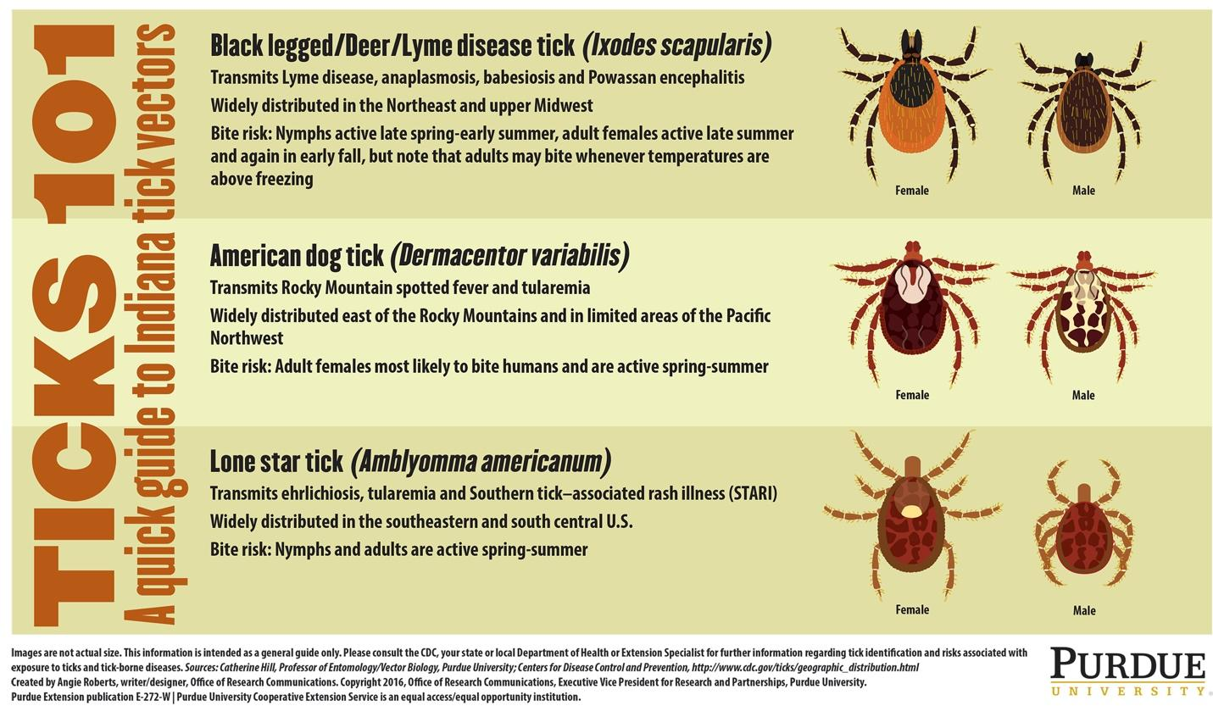

- Resources

There are many available resources concerning the information in this guide. Please use these references for more information on the topic discussed in this safety guide.

- On Campus

Environmental Health & Safety: EHS is available for various hazard information and hazard evaluations.
865-974-5084
https://ehs.utk.edu/

Workers Compensation: More information about UT’s workers’ compensation policies and how to report an incident can be found here: https://riskmanagement.tennessee.edu/workers-compensation/.

UT Police: UT Police can be reached at 865-974-5084 (emergency line) or 865-974-3114 (non-emergency line)

Study abroad: For more information on study abroad programs. https://programsabroad.utk.edu/

Institutional Animal Care and Use Committee (IACUC): Research with animals, including wild animals, must be reviewed and approved by the committee prior to beginning research. Information is available here: https://iacuc.utk.edu/ or call 865-974-3631.

Student Health Center: The Student Health Center offers telemedicine, vaccinations, and other health related services. https://studenthealth.utk.edu/

- Off Campus

CPR/First Aid: First aid and CPR are available through several different outlets. The American Red Cross courses can be found here: www.redcross.org/training/first-aid-cpr

General health, disease, and travel information: The Centers of Disease Control and Prevention (CDC) offers a website that describes many topics related to health, disease, and travel, both domestic and international: www.cdc.gov

Medical: Information about a variety of diseases and illnesses can be found on their website: www.webmd.com (This resource SHOULD NOT be used to self-diagnose in the place of visiting a doctor)

Diseases: The CDC offers more detailed information about many diseases related to travel. https://www.cdc.gov/diseasesconditions/index.html

Tennessee Department of Health: The TN Dept of Health offers information regarding a wide variety of services including infectious disease information, health data, and healthcare locations. https://www.tn.gov/health

Weather: More information about current and expected weather conditions can be found at www.weather.gov. More information on weather safety in various scenarios can be found at https://www.weather.gov/safety/.

Impure water: Impure Water: The CDC provides information waterborne diseases. http://www.cdc.gov/healthywater/.

Research Vessel Safety: Addresses field operations aboard research vessels or larger watercraft. https://www.unols.org/document/research-vessel-safety-standards-rvss

- North America

General safety: For more information on outdoor and recreational safety: https://www.fs.fed.us/safety/outdoor/.

Hunting: To get more information concerning hunting seasons and regulations, contact the U.S. Forest Service on-line at http://www.fs.fed.us/.

Lyme Disease: The American Lyme Disease Foundation provides information about the disease at http://www.aldf.com/.

Hantavirus: The CDC has detailed information about Hantavirus. https://www.cdc.gov/hantavirus/

Poisonous Plants: More information about poison plants, including photos, can be found at http://poisonivy.aesir.com/.

- International

Travel Health & Outbreaks: Updated information about disease outbreaks and international travel health can be found from the World Health Organization (WHO). http://www.who.int/ith/en/

Advisories: Travel advisories are announced through the U.S. Department of State. Current travel warnings, public announcements, and consular information sheets can be obtained online at: http://travel.state.gov/

- Safety Resources for Specific Areas of Study

Agriculture/Rural Studies: UC Agriculture and Natural Resources (UC ANR) provides excellent “Safety Notes” for a variety of outdoor and field activities. http://safety.ucanr.edu/Safety_Notes/

Geology/Earth Sciences:
Safety & Health for Field Operations (USGS) – handbook 445-3-H: https://www.usgs.gov/about/organization/science-support/survey-manual/handbooks

Polar Sciences:
US Antarctica Program, Arctic Sciences (NSF): https://nsf.gov/geo/plr/pehs/index.jsp

Wildlife Biology:
Guidelines for use of wild animals in research and teaching (American Society of Mammologists): https://www.mammalsociety.org/uploads/committee_files/CurrentGuidelines.pdf
Guidelines to the Use of Wild Birds in Research (Ornithological Council): http://www.ebd.csic.es/documents/240051/0/Guidelines_to_the_use_of_wild_birds_in_research.pdf/4080feb3-01f7-48a3-9712-be5c95e9f8e5
Science Guidelines (American Fisheries Society): https://fisheries.org/policy-media/science-guidelines/
Resources, Collection & Curation Practices (American Society of Ichthyologists & Herpetologists): https://asih.org/
Precautions for Zoonotic Disease Prevention in Veterinary Personnel (National Association of State Public Health Veterinarians): http://nasphv.org/Documents/VeterinaryStandardPrecautions.pdf
Fish & wildlife training modules (Canadian Council on Animal Care): https://www.ccac.ca/en/training/modules/
Health Risks for Marine Mammal Works (UC Davis Vet Medicine, 2008): https://www.int-res.com/articles/dao_oa/d081p081.pdf
Disease Precautions for Hunters (AVMA): https://www.avma.org/resources/public-health/disease-precautions-hunters

Appendix 1. Emergency information for common sites in Eastern Tennessee

Closest hospital to University of Tennessee - Knoxville
University of Tennessee Medical Center
1924 Alcoa Hwy, Knoxville, TN 37920
Phone: (865) 305-9000

UT Police: 865-974-3114
Knoxville Police Department Non-emergency: 865-215-7450
EMERGENCY CALL 911.

Closest hospital to UTK Field Station
LeConte Medical Center
742 Middle Creek Rd, Sevierville, TN 37862
Phone: (865) 446-8800

Pittman Center Police (only 2 officers): 865-436-5499
Sevier County Sheriff: 865-453-4668
EMERGENCY CALL 911.

Closest hospitals to Great Smoky Mountains NP (Tennessee side)
If near Gatlinburg:
LeConte Medical Center
742 Middle Creek Rd, Sevierville, TN 37862
Phone: (865) 446-8800
Closest hospitals to Great Smoky Mountains NP (Tennessee side) continued

If near Greenbrier:
LeConte Medical Center
742 Middle Creek Rd, Sevierville, TN 37862
Phone: (865) 446-8800

If near Cosby:
Newport Medical Center
435 2nd St, Newport, TN 37821
Phone: (423) 625-2200

If near Townsend/Maryville:
Blount Memorial Hospital
907 E Lamar Alexander Pkwy, Maryville, TN 37804
Phone: (865) 983-7211

Ranger Stations in the Great Smoky Mountains NP:

Sugarlands Little River Ranger Station: 865-436-1200
Great Smoky Mountains Ranger Office: 865-436-1227
Cades Cove Ranger Station: 865-448-4103
Cosby Ranger Station: 423-487-5418
EMERGENCY CALL 911.

Appendix 2. Field Safety Plan Template

A field safety plan serves as a tool to document your hazard assessment, communication plan, emergency procedures, and training. This plan should identify hazards, as well as precautions and actions taken to address and mitigate those hazards. Instructions:
- .Complete this field safety plan: insert specifics for your site and operations, delete irrelevant sections.
- Complete appropriate training for your site and operations (e.g. first aid, heat illness, task-specific training).
- Obtain immunizations and prophylaxis for your destination, if applicable (schedule 8 weeks in advance).
Hold a pre-trip meeting with your group and/or supervisor to review your field safety plan, travel logistics, pack list (including first aid kit), personal safety and security concerns, and any remaining training needs.

Field Site Location: | Descriptive name of research location (e.g. Great Smoky Mountains NP, North Carolina; Tortuguero, Costa Rica)
Activity Description: | Type, length, and purpose of activity (e.g. hiking 3-4 miles, collecting specimens, etc.)
Plan Created for: | Name of Research Group / Course / Trip Leader | Date of revision: | Mo-Day-Yr
Date(s) of Travel: | Start date, duration, expected return to campus

Site Information
Location | Latitude: XX.XX (from GPS/Map) |  |  | Longitude: XX.XX (from GPS/Map)
Site Information | Elevation, terrain, environment.
Travel to Site | How will participants get to the field site? Note any dangerous roads, conditions.
Site Access | Are there any particular restrictions or challenges to accessing site? Note any alternate routes or suggested parking areas; gate access codes, etc. Make special note if isolated or remote.
Environmental  Hazards | Describe any dangerous wildlife, insects, endemic diseases, poisonous plants, etc. that participants may encounter. Note intended mitigation measures; discuss prior to trip.
Security | High risk for harassment or violence? Note intended mitigation measures; discuss prior to trip. For international travel, check the U.S. State Department travel site for current travel alerts and look up the security rating for your destination via the Worldcue Trip Planner.
No Go Criteria | What are the conditions under which approach to - or activities at - the site should be stopped or canceled? e.g. heavy rains, electrical storms, snow, temperatures > 100 degrees, within 2 hours of high tide, wave heights over 1 meter, etc.  For complex trips, consider using the GAR Risk Management Model.
Expected Weather | Note extreme conditions that could impact the trip or require additional planning, (e.g. high heat, wind, rain, snow, approaching storm).
Drinking Water Availability | ☐ Plumbed water available ☐ Water cooler with ice provided ☐ Bottled water provided  ☐ Natural source and treatment methods (e.g. filtration, boiling, chemical disinfection):
Access to Shade/Shelter | If forecast exceeds 80°, shade must be provided by natural or artificial means for rest breaks.  ☐ Building structures ☐ Trees ☐ Temporary Canopy/Tarp ☐ Vehicle with A/C ☐ Other:
High Heat Procedures | Required when temperatures are expected to exceed 95° F: If possible, limit strenuous tasks to morning or late afternoon hours. Rest breaks in shade must be provided at least 10 minutes every 2 hours (or more if needed). Effective means of communication, observation and monitoring for signs of heat illness are required at all times. Pre-work safety discussion required.  ☐ Direct supervision ☐ Buddy system ☐ Reliable cell or radio contact ☐ Other:
Emergency Services and Contact Information
Local Contact | Name, address & phone #, may be a local colleague/institution, reserve manager, USFS office, etc.  Lodging location: name, address, phone # | University Contact  Not on trip. Provide a copy of this plan. |  |  |  | Name, number, email; may be a Professor/PI, department contact, supervisor back on campus, etc.  Frequency of check ins: daily, at end of work day, etc.
Emergency Medical Services (EMS) | Procedures for contacting emergency medical services.
Nearest Emergency Department (ED) | Evacuation plan and transportation options to the nearest Emergency Department; include estimated transport time, contact information and driving directions from the site to the nearest provider of emergency medical care. Attach map with specific directions.
Cell Phone Coverage | Primary Number:  Coverage: good, spotty, none  Nearest location with coverage: |  | Satellite phone/device |  | Device carried? ☐yes ☐no  Type/number:
Nearby Facilities | What facilities are available at or near the site: restrooms, water, gas, public phone, store? If not, where are the nearest services along the route?
Side Trips | Are side trips planned or allowed during free time? Before or after the planned activities? Are there restrictions, specific rules, or expected code of conduct?
Participant Information
Field Team/ Participants | Is anyone working alone? ☐ Yes ☐ No If yes, develop a communications plan with strict check-in procedures; if cell coverage is unreliable, carry a satellite communication device or personal locator beacon.  Primary Field Team Leader: Name, phone number  Secondary Field Team Leader: Name, phone number  ☐ Field Team/Participant list is attached as training documentation  ☐ Other attachment: e.g. course roster
Physical Demands | List any physical demands required for this trip and training/certification provided. e.g. diving, swimming, hiking, climbing, high altitudes, respirators, heights, confined or restricted spaces, etc. (consult with EH&S regarding appropriate training & documentation).
Mental Demands | List any unique mental demands required for this trip, e.g. long travel days, high stress environments, different cultural norms, etc.
First Aid Training  & Supplies | First Aid and CPR training is recommended.  List team members trained in first aid and the type of training received.  Location and description of group medical/first aid kit: Who is carrying it, where is it stored. Brief description of contents.
Immunizations or Medical Evaluation | List required immunizations/prophylaxis or required medical evaluation, if applicable.

Equipment and Activities – Consult with EH&S for specific training and requirements.
Research Activities | Briefly describe the goal of your field operations, e.g. collection of samples, observation of animals/environment, interviews with human subjects, etc.…
Field  Transportation | What vehicles will be used during field operations? e.g. chartered boat, paddle craft, car, ATV, truck with trailer, snowmobile, chartered plane or helicopter, etc.
Research Tools | Briefly describe tools or equipment that will be used to access the research site or during research activities. Indicate specific training required before use, e.g. sharps (knives, razors, needles), hand tools, chainsaws, power tools, heavy machinery, tractors, specialty equipment, firearms; lasers, portable welding/soldering devices; other hazardous equipment or tools.
Other Research Hazards | Describe other potential research-associated hazards e.g. handling or shipping hazardous materials (chemical, biological, radiation, and explosives), handling animals, climbing or working at heights, rigging; shoring/trenching, digging/entering excavations, caves, other confined spaces; drone use.
Personal Protective Equipment | Required—e.g. boots, safety glasses, PFDs, hardhats, etc.  Recommended – e.g. walking sticks, gloves, long pants, hats, insect repellant, sunscreen
Additional Considerations
Insurance
International Activities | Check with the Global Engagement Office (GEO) regarding required approvals. Visas, permits, finances, import/export controls, transportation of specialized equipment, and data security must be considered.
Personal Safety & Security | Personal safety risks during free time should be considered and discussed in advance, e.g., alcohol or drug use, leaving the group, situational awareness, sexual harassment, or local crime/security concerns. Review expectations and set the tone for a safe, successful trip.  High Risk Travel:  Check the U.S. State Department travel site for current travel alerts and you may use the Worldcue Trip Planner ‘Location Intel’ tab to generate a security brief for your destination.  UC also offers pre-travel security risk planning, in-country security risk assessments, and contingency planning for those traveling to high risk destinations.
Campus Contacts
UTK PD | utpolice.utk.edu  865-974-0808
University Health Services | Studenthealth.utk.edu  Students: Access care via the online appointment system or call at 865-974-5080.
EHS | ehs.utk.edu  865-974-9586 (One-Call) or 865-974-5084 (main line); safety@utk.edu

Signature of PI/Supervisor:
I acknowledge this safety plan has been prepared for field work under my supervision.

Name | Signature | Date | Phone Number

Field Team/Participant Roster - Training Documentation
I verify that I have read this Field Safety Plan, understand its contents, and agree to comply with its requirements.
Name/Phone Number | Signature | Date | Emergency Contact/Phone Number

